**ASSIGNMENT - 11.4**

**Problem Statement:**

Twitter data analysis Write a pig script to find the count of each Hashtag in the dataset. You can download the twitter data from the below link:

**Input:**

<https://github.com/prateekATacadgild/DatasetsForCognizant/blob/master/tweets.rar>

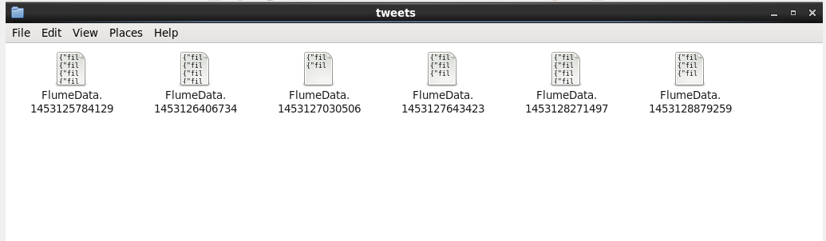

**Pig Script:**

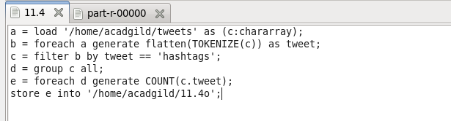

**Output:**

